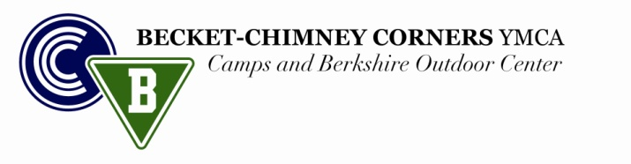

A LETTER TO MY CAMP COUNSELOR ~ 2016

Circle Session(s): 1 2 Starter A Starter B

My name is . My friends call me .

I have finished the grade in school (June 2016).

The things I like to do most with my friends are:

The things I like most about my home are:

What I like most about school is: ____________

When at school, the things I like to do least are:

My friends describe me as:

My best friends are people who:

The qualities I like most in people are:

I am worried or upset when:

I want to be in camp because:

Over Please

I would like to have a counselor who:

The three activities that I am most looking forward to are: __________________________________________________________

When I get to camp, the things I want to achieve or accomplish are:

If you have any questions or concerns about camp, please write them here: ______

I agree to do my best, abide by all Becket-Chimney Corner rules, and work positively toward a successful summer.

Signature: Date:

☺ ☺ ☺ ☺ ☺ ☺ ☺ ☺ ☺ ☺ ☺ ☺ ☺ ☺ ☺ ☺ ☺ ☺ ☺ ☺ ☺ ☺ ☺ ☺ ☺ ☺ ☺ ☺ ☺ ☺ ☺ ☺ ☺ ☺ ☺ ☺ ☺

FOR FORMER CAMPERS ONLY

If you’ve been a camper at Becket-Chimney Corners previously, please answer below.

While at camp during the summer, the things that helped me the most were:

I have decided to return to camp because:

Cabin Experience: Year Cabin Year Cabin

